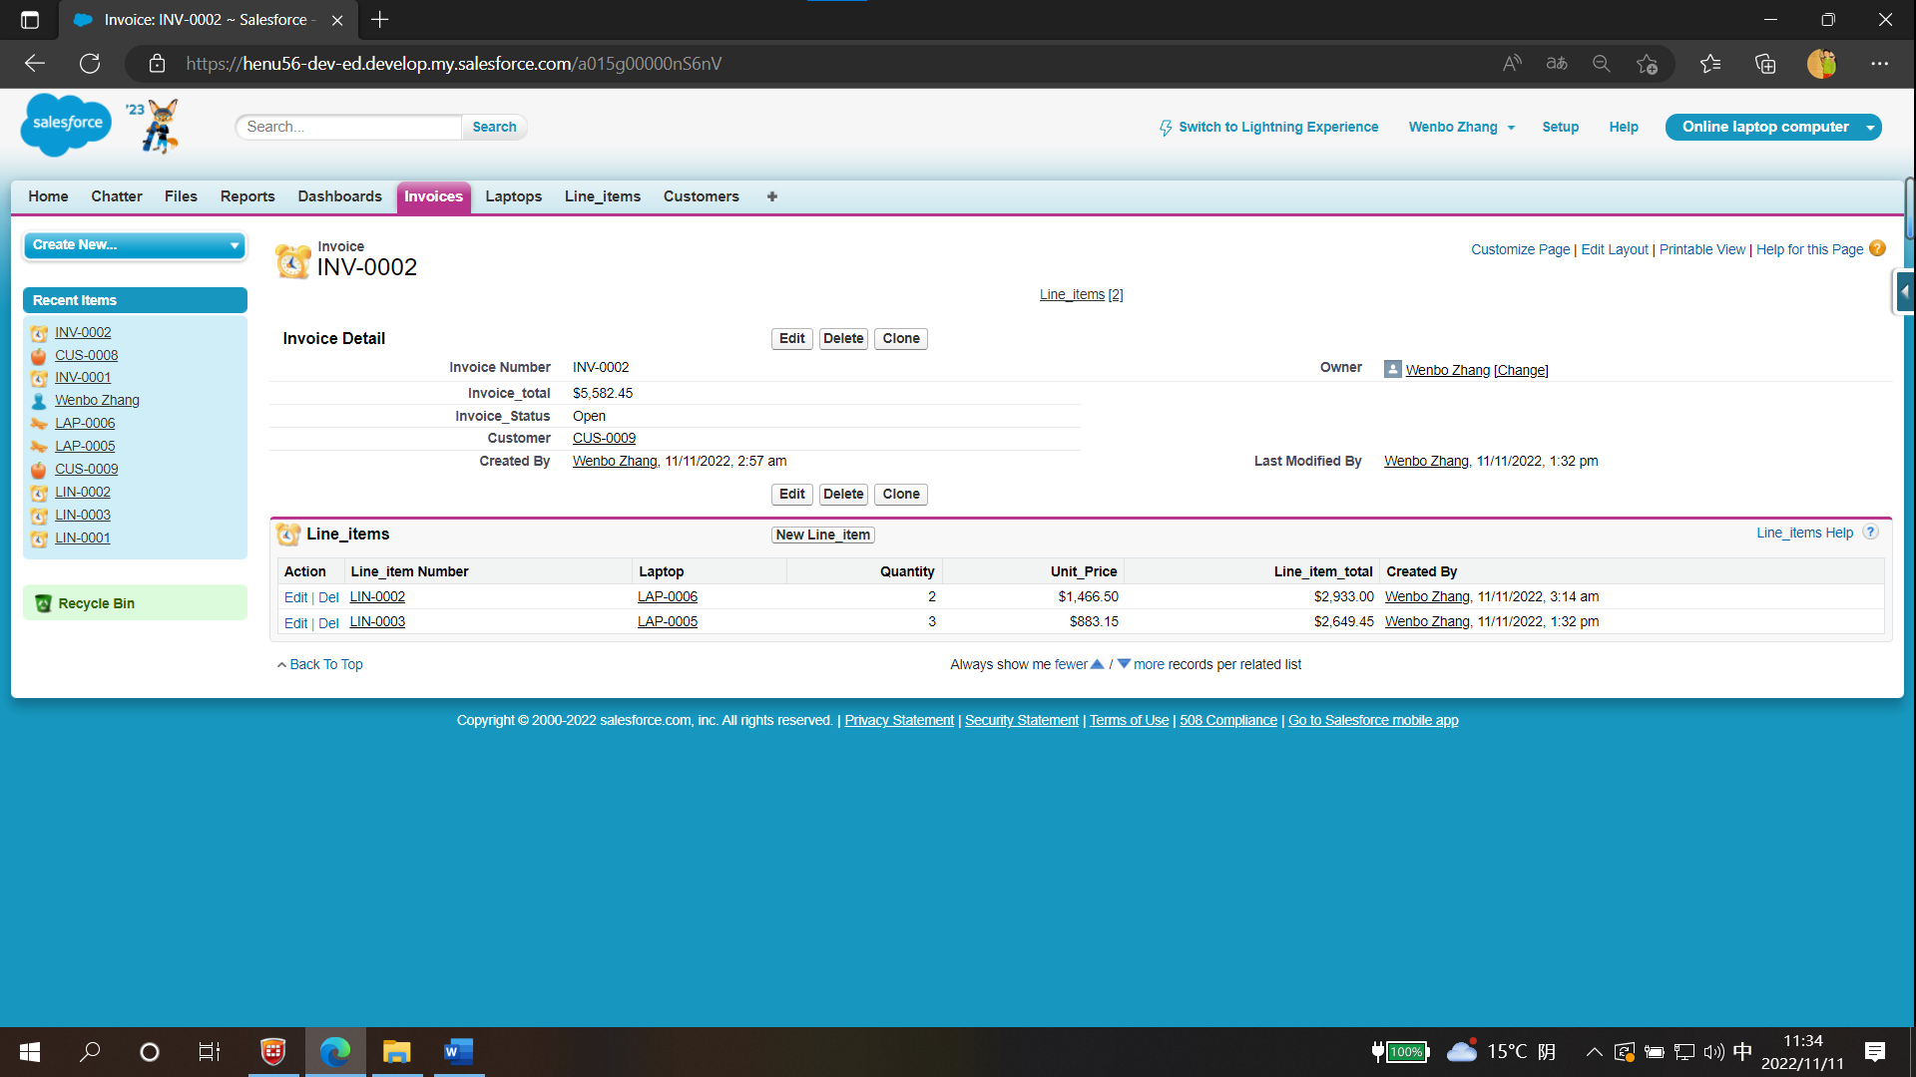

Figure 1 Invoice INV-0002

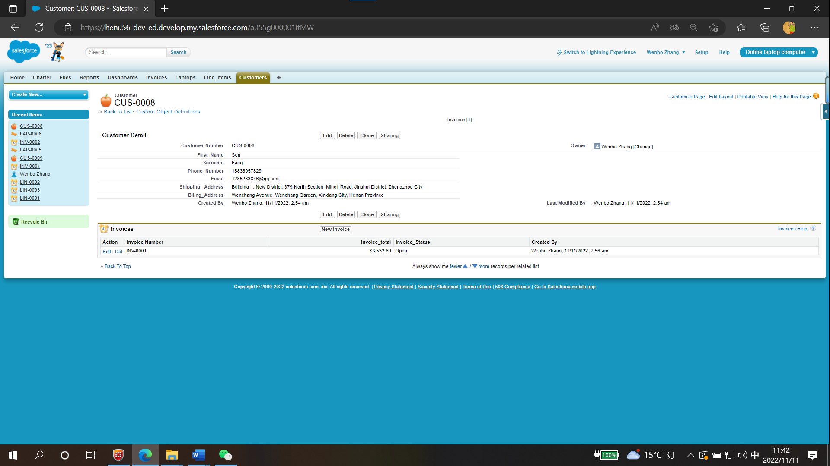

Figure 2 Customer FangSen

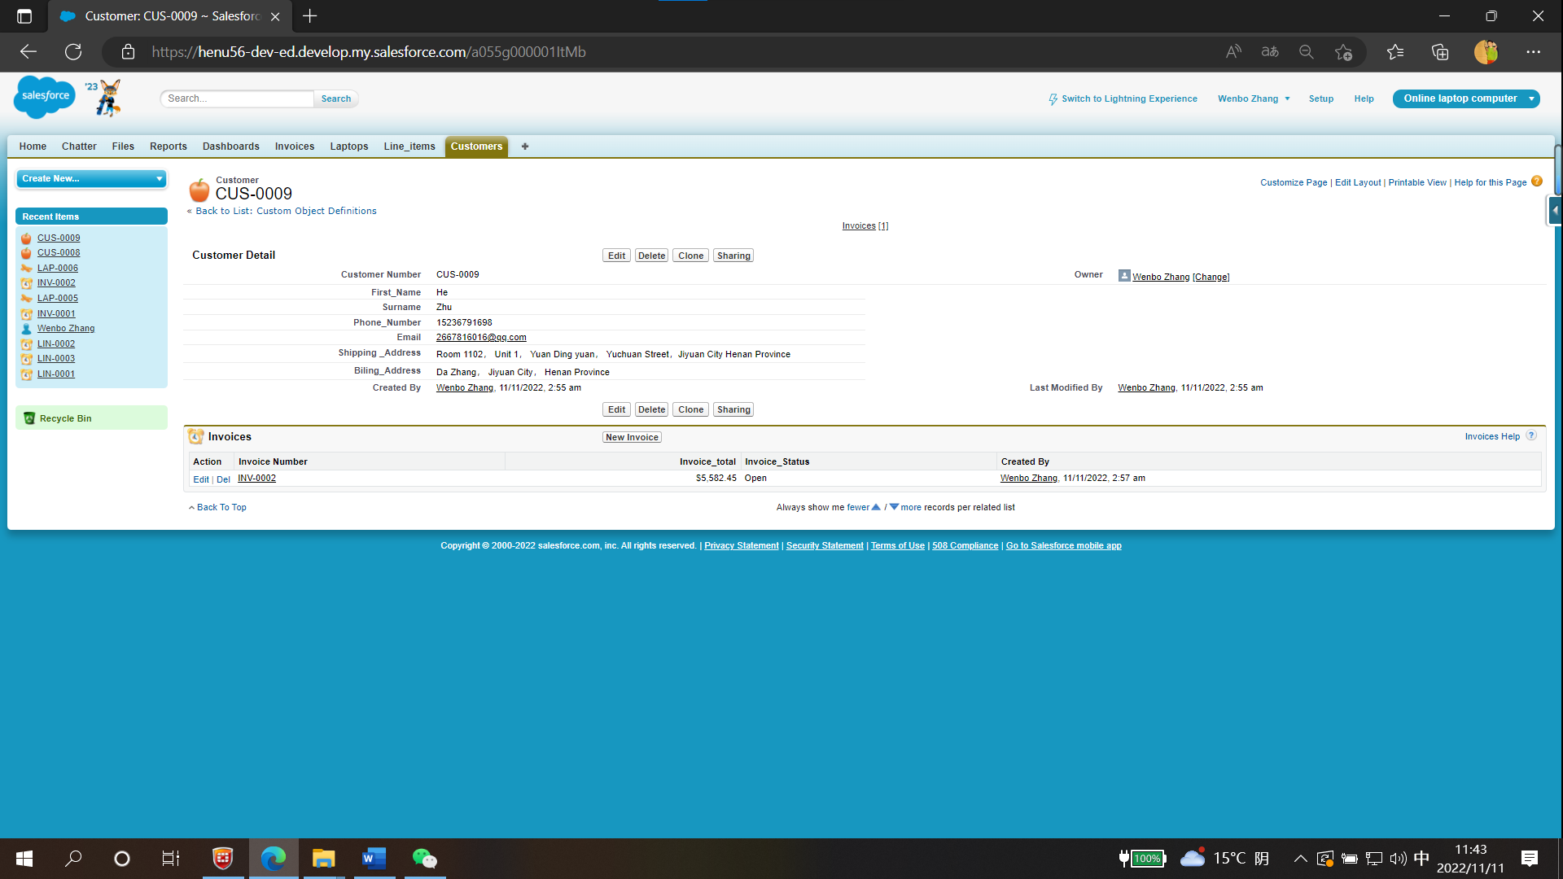

Figure 3 Customer ZhuHe

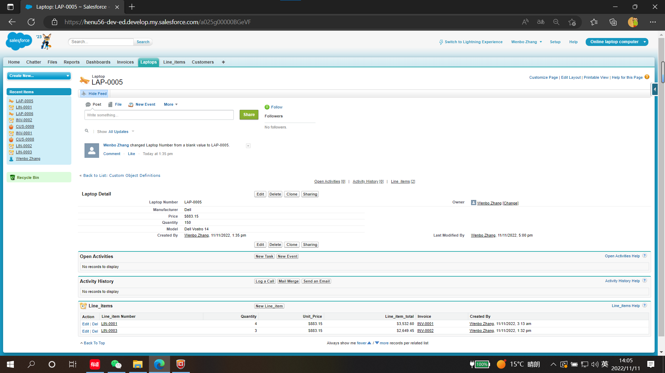

Figure 4 Laptop Dell Vostro 14

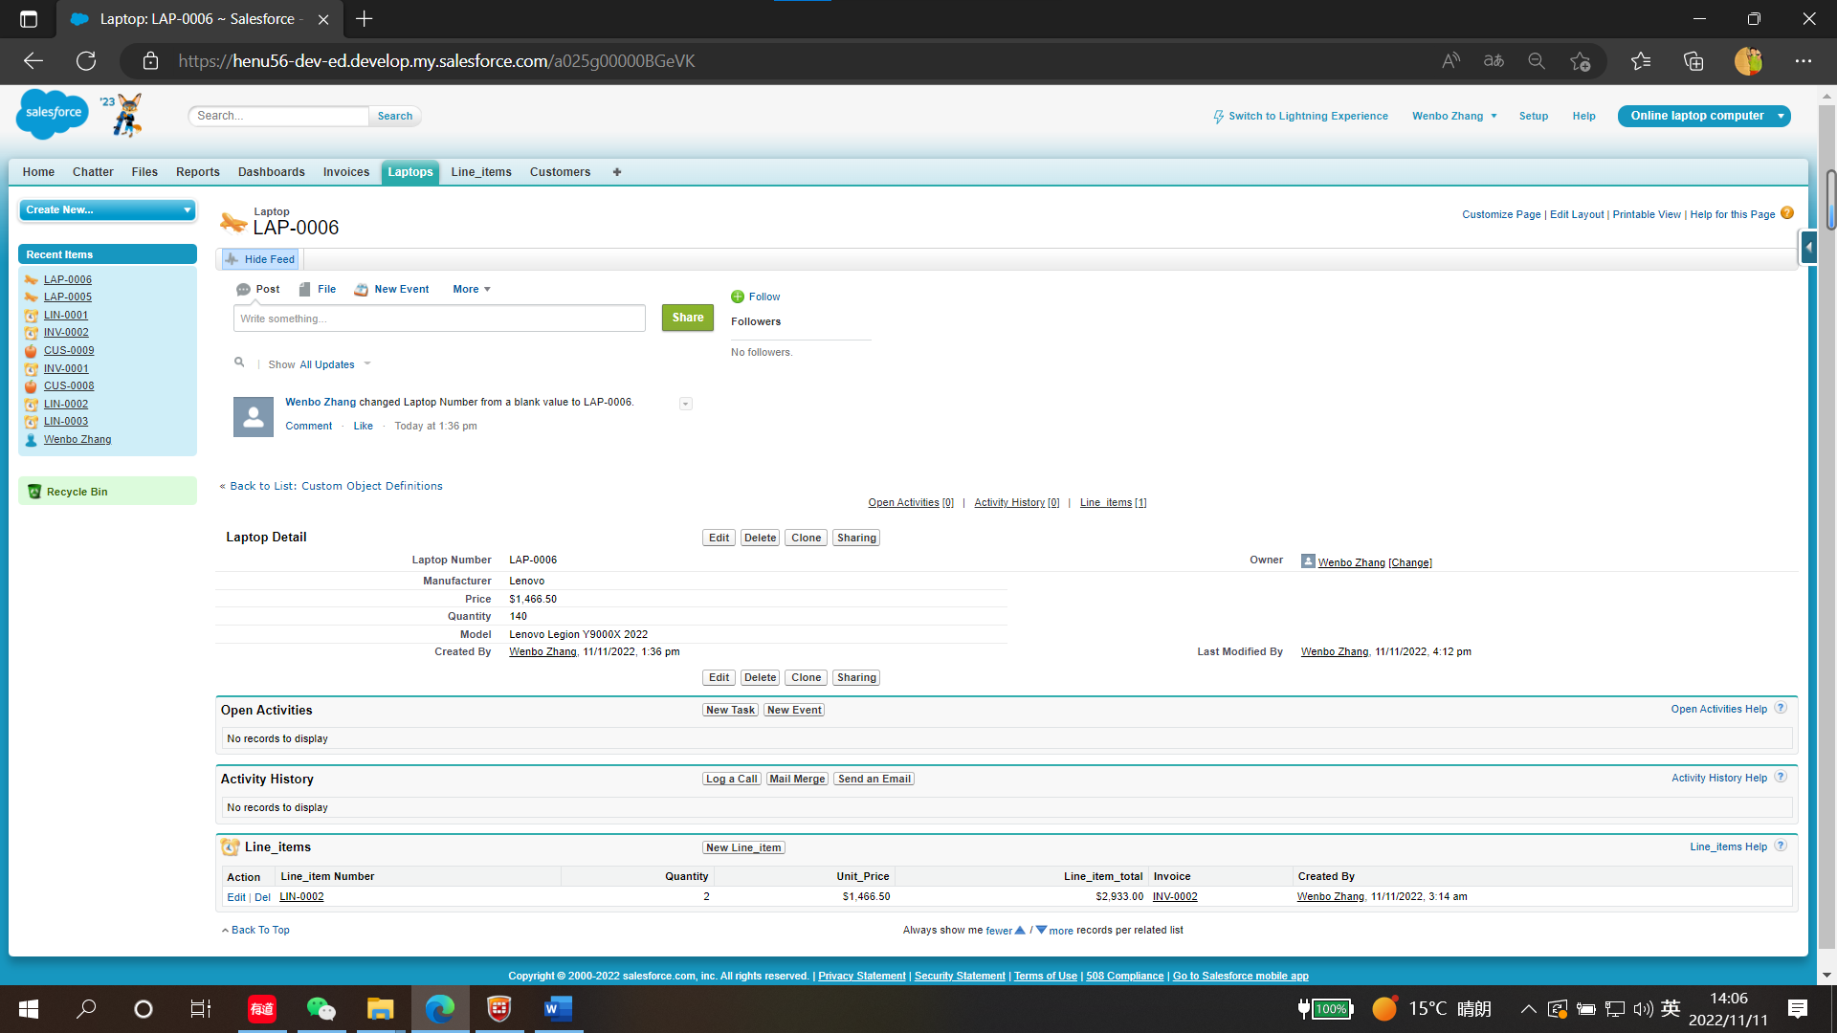

Figure 5 Laptop Lenovo Legion Y9000X 2022